Erster Langer Durchlauf:

Grid Resolution 16

#end conditions:

nrmsd_delta_end_condition = 0.000001

desired_nrmsd = 0.1

analysis_number_end_condition = 100

Number of zooms completed = 99

Number of simulations completed = 25344

NRMSD_Population min = 0.001864

Improved parameter = frpm

From value: 0.010407 to value: 0.010276

Delta NRMSD = 2e-06

Elapsed time in seconds: 11048.69

Execution time in seconds: 11048.97 -> 3 Stunden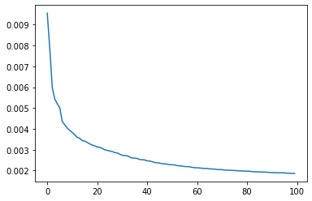

Zweiter langer durchlauf:

Grid Resolution 16

#end conditions:

nrmsd_delta_end_condition = 0.000001

desired_nrmsd = 0.1

analysis_number_end_condition = 200

Number of zooms completed = 109

Number of simulations completed = 27904

NRMSD_Population min = 0.001832

Improved parameter = alln

From value: 1039.757954 to value: 1039.088517

Delta NRMSD = 0.0

Elapsed time in seconds: 11989.48

Execution time in seconds: 11989.63 -> 3,3 Stunden

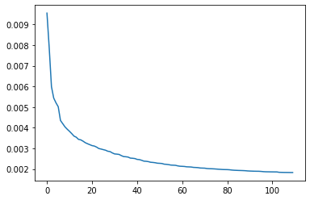

Dritter langer durchlauf:

Grid Resolution 16

#end conditions:

nrmsd_delta_end_condition = 0.000001

desired_nrmsd = 0.1

analysis_number_end_condition = 400

Number of zooms completed = 81

Number of simulations completed = 20736

NRMSD_Population min = 0.001889

Improved parameter = frpm

From value: 0.010285 to value: 0.010271

Was edge value

Delta NRMSD = 0.0

Elapsed time in seconds: 8858.22

Execution time in seconds: 8858.63 -> 2,4 stunden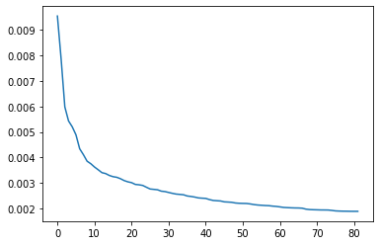

Vierter Langer Durchlauf:

grid_resolution = 20

#end conditions:

nrmsd_delta_end_condition = 1e-6

analysis_number_end_condition = 100

Number of zooms completed = 99

Number of simulations completed = 31680

NRMSD_total min = 0.78488312

Improved parameter = frpm

From value: 0.013083 to value: 0.012889

Was mid value

Delta NRMSD = 3.588e-05

Elapsed time in seconds: 15565.01

Execution time in seconds: 15565.2 -> 4.2 Stunden

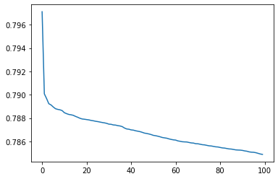

Fünfter Langer Durchlauf:

grid_resolution = 20

#end conditions:

nrmsd_delta_end_condition = 1e-6

analysis_number_end_condition = 250

Number of zooms completed = 249

Number of simulations completed = 79680

NRMSD_total min = 0.77928931

Improved parameter = sd

From value: 0.209156 to value: 0.210442

Was mid value

Delta NRMSD = 4.483e-05

Elapsed time in seconds: 39912.48

Execution time in seconds: 39912.79 -> 11 Stunden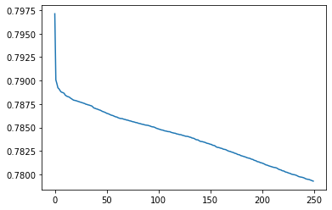

6ter Durchlauf:

grid_resolution = 10

nrmsd_delta_end_condition = 1e-6

analysis_number_end_condition = 400

parameter_move_start_end_value = 0.2

parameter_divergence = 0.3

Number of zooms completed = 59

Number of simulations completed = 11328

NRMSD_total min = 0.78588588

Improved parameter = lfpf

From value: 1.019005 to value: 1.00511

Was mid value

Delta NRMSD = 0.0

Elapsed time in seconds: 5488.99

Execution time in seconds: 5489.41 -> 1,5 Stunden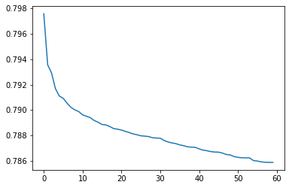

todo:

1. Jeden parameter einmal alleine durchlaufen lassen und neue start und end value in excel schreiben
2. Teamviewer für analyse auf meine desktop einrichten
3. Verlauf der parameter anzeigen, um wie viel prozent wurde der wert verändert
4. Speichern ob bester wert ein edge value ist
5. Dynamische Änderung von parameter_move_start_end_value einbauen

grid_resolution = 20

nrmsd_delta_end_condition = 1e-7

analysis_number_end_condition = 300

parameter_move_start_end_value = 0.25

parameter_divergence = 0.5

NRMSD_total min = 0.05361891

Was end value

Improved parameter = sfpc

From value: 78.308307 to value: 78.442108

Change: 0.001709

Delta NRMSD = 8e-08

Elapsed time in seconds: 41903.78

Execution time in seconds: 41904.31 -> 11,6 Stunden -> 46,5 kernstunden

End Bedingung: Delta NRMSD

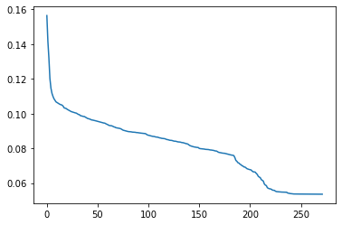

29.12.2022

grid_resolution = 28

nrmsd_delta_end_condition = 1e-8

analysis_number_end_condition = 300

parameter_move_start_end_value = 0.2

parameter_divergence = 0.4

Number of zooms completed = 399

Number of simulations completed = 178752

NRMSD_total min = 0.05494482

Was end value

Improved parameter = pl

From value: 0.251193 to value: 0.251327

Change: 0.000533

Delta NRMSD = 3.13e-06

Elapsed time in seconds: 88386.44

Execution time in seconds: 88386.65

no_of_mid_values: 215

no of start values : 58

no of start values : 127

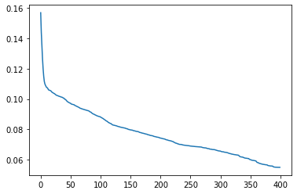

30.12.2022

grid_resolution = 35

nrmsd_delta_end_condition = 1e-8

analysis_number_end_condition = 300

parameter_move_start_end_value = 0.2

parameter_divergence = 0.4

File "C:\Users\Tim Schell\Documents\GitHub\Limits-to-Growth-Masterprojekt-TH-Koeln-2022\analysis.py", line 101, in <module>

if parameter_list_full.iloc[NRMSD_index-1,parameter_index] < parameter_list_full.iloc[NRMSD_index, parameter_index] and parameter_list_full.iloc[NRMSD_index+1,parameter_index] > parameter_list_full.iloc[NRMSD_index,parameter_index]:

File "G:\Anaconda\lib\site-packages\pandas\core\indexing.py", line 960, in __getitem__

return self.obj._get_value(*key, takeable=self._takeable)

File "G:\Anaconda\lib\site-packages\pandas\core\frame.py", line 3613, in _get_value

return series._values[index]

IndexError: index 560 is out of bounds for axis 0 with size 560

05.01.2023

grid_resolution = 10

nrmsd_delta_end_condition = 1e-8

analysis_number_end_condition = 100

parameter_move_start_end_value = 0.2

parameter_divergence = 0.4

Number of zooms completed = 99

Number of simulations completed = 15840

NRMSD_total min = 0.07754018

Was mid value

Improved parameter = sfpc

From value: 142.706492 to value: 136.950222

Change: 0.040336

Delta NRMSD = 0.0005353

Elapsed time in seconds: 8181.0

Execution time in seconds: 8181.21

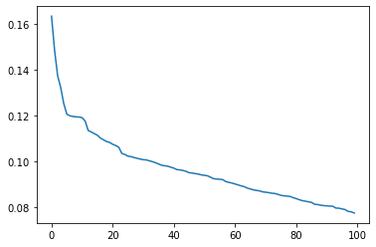

Note: test, due to last error

05.01.2023

grid_resolution = 16

nrmsd_delta_end_condition = 1e-8

analysis_number_end_condition = 400

parameter_move_start_end_value = 0.5

parameter_divergence = 0.5

Number of zooms completed = 218

Number of simulations completed = 55808

NRMSD_total min = 0.07301974

Was end value

Improved parameter = alln

From value: 40932655.818117 to value: 60034561.866576

Change: 0.466667

Delta NRMSD = 1e-08

Elapsed time in seconds: 28330.97

Execution time in seconds: 28331.23

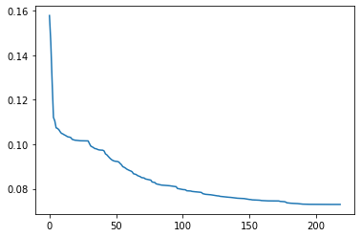

Note: no nri change

06.01.2023

grid_resolution = 16

nrmsd_delta_end_condition = 1e-8

analysis_number_end_condition = 400

parameter_move_start_end_value = 0.5

parameter_divergence = 0.5

Analysis parameter: nri = standard

Number of zooms completed = 141

Number of simulations completed = 36096

NRMSD_total min = 0.06220417

Was mid value

Improved parameter = lfpf

From value: 1.025 to value: 0.981667

Change: 0.042276

Delta NRMSD = 0.0

Elapsed time in seconds: 18828.46

Execution time in seconds: 18828.7

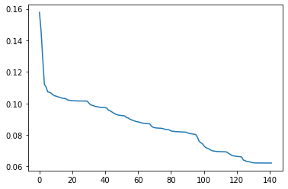

Note: nri changed

08.01.2023

grid_resolution = 16

nrmsd_delta_end_condition = 1e-8

analysis_number_end_condition = 400

parameter_move_start_end_value = 0.5

parameter_divergence = 0.2

Note: to see effect of move…

File "C:\Users\Tim Schell\Documents\GitHub\Limits-to-Growth-Masterprojekt-TH-Koeln-2022\analysis.py", line 101, in <module>

if parameter_list_full.iloc[NRMSD_index-1,parameter_index] < parameter_list_full.iloc[NRMSD_index, parameter_index] and parameter_list_full.iloc[NRMSD_index+1,parameter_index] > parameter_list_full.iloc[NRMSD_index,parameter_index]:

File "G:\Anaconda\lib\site-packages\pandas\core\indexing.py", line 960, in __getitem__

return self.obj._get_value(*key, takeable=self._takeable)

File "G:\Anaconda\lib\site-packages\pandas\core\frame.py", line 3613, in _get_value

return series._values[index]

IndexError: index 256 is out of bounds for axis 0 with size 256

09.01.2023

grid_resolution = 16

nrmsd_delta_end_condition = 1e-8

analysis_number_end_condition = 400

parameter_move_start_end_value = 0.5

parameter_divergence = 0.3

Note: to see effect of move…

Traceback (most recent call last):

File "C:\Users\Tim Schell\Documents\GitHub\Limits-to-Growth-Masterprojekt-TH-Koeln-2022\analysis.py", line 101, in <module>

if parameter_list_full.iloc[NRMSD_index-1,parameter_index] < parameter_list_full.iloc[NRMSD_index, parameter_index] and parameter_list_full.iloc[NRMSD_index+1,parameter_index] > parameter_list_full.iloc[NRMSD_index,parameter_index]:

File "G:\Anaconda\lib\site-packages\pandas\core\indexing.py", line 960, in __getitem__

return self.obj._get_value(*key, takeable=self._takeable)

File "G:\Anaconda\lib\site-packages\pandas\core\frame.py", line 3613, in _get_value

return series._values[index]

IndexError: index 256 is out of bounds for axis 0 with size 256

17.01.2023

grid_resolution = 28

nrmsd_delta_end_condition = 1e-8

analysis_number_end_condition = 50

parameter_move_start_end_value = 0.5

parameter_divergence = 0.5

Number of mid values: 19

Number of edge values: 6

NRMSD min: 0.5324497502

Execution time in seconds: 5858.15

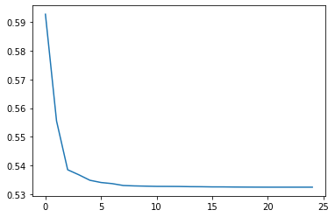

17.01.2023

grid_resolution = 40

nrmsd_delta_end_condition = 5e-9

analysis_number_end_condition = 20

parameter_move_start_end_value = 0.5

parameter_divergence = 0.75

Number of zooms completed = 19

Number of simulations completed = 12160

NRMSD_total min = 0.40682025

From value: 0.023896 to value: 0.023935

Relative change: 0.001632

Elapsed time in seconds: 6028.1

Number of mid values: 17

Number of edge values: 3

NRMSD min: 0.4068202549

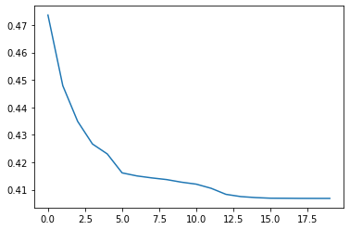

18.01.2023

grid_resolution = 40

nrmsd_delta_end_condition = 1e-8

analysis_number_end_condition = 100

parameter_move_start_end_value = 0.5

parameter_divergence = 0.75